West Hull Ladies
RRC

June Newsletter

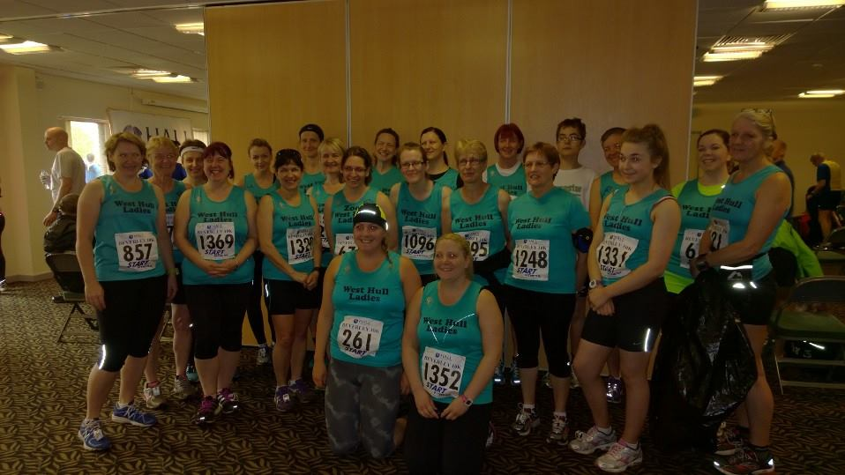

West Hull Ladies


WEST HULL LADIES RRC
COMMITTEE MEETING

2nd June 2014
Present Jill, Zoe, Debbie, Maria, Ann, Hayley, Sandra, Linda, Amanda
1. Apologies received from Annette, Sally, Rachael, Lisa
2. Minutes of previous meeting approved
3. Matters arising - dates needed for HAN meetings - Sandra to obtain.
4. LiRF Amanda stated that she had/was submitting forms asking for £80 towards the cost of the courses for which Carol and Linda had been nominated. Debbie informed the committee of the Club’s finances which did not run at much of a profit the outgoings being nearly as much as the income generated through membership. This had to be borne in mind.
5. Amanda produced a document she had prepared giving details of the Great British Relay. We were to run the Barton to Hull leg on the 1st July. A discussion took place about various roles that needed to be assigned. Rachael C had offered to be Facebook co-ordinator ( prior to the meeting) and Linda the Communicator using mobile phone. The leg had to be completed in a specified time and it was agreed the faster ladies would run the first half ( 8 min miles) and the other ladies to be picked up on the north side of the Humber - location to be decided. Amanda to send email to club members detailing this, also to arrange recce of the route.
6. Hayley told the committee about a sponsored trek she was doing on behalf of Dove House Hospice and how she was committed to raising £2000+ funds. She asked if the Club members would help in anyway they could. Members were positive speaking of holding cake/coffee mornings. Hayley to prepare and send out email to club members who hopefully would help fundraise with Hayley. The trek is to take place in May 2015.
7. Amanda asked for any LiRF trainer available for 16th June. Ann volunteered.

North Lincolnshire Half Marathon

Jill
Preparation for this race had not been ideal. Since February, I have been struggling with my knee, which was injured after I had managed to throw myself over a tree root on Cottingham Road! However I had not been doing anything like enough miles if I’m honest, coming up to the race, having been busy at work, making it difficult to get to the club in time for running nights. Excuses made…I also had been suffering a bit of a lack of confidence with my running. Looking at my running stats from last year…I was wondering how I had actually achieved the times that I did. I wonder whether this is a woman thing or whether all runners go through these phases…but I find that if I don’t run for a few days…or if I do some poor times…I think that I can’t actually do it any more…which is daft really!! Anyway, I was actually pleased that I felt that I was fit enough to have a go at this run, but wondered whether I could dip under 10 minute miles, to get anywhere near my time from last year’s race of just over 2 hours 4 mins.

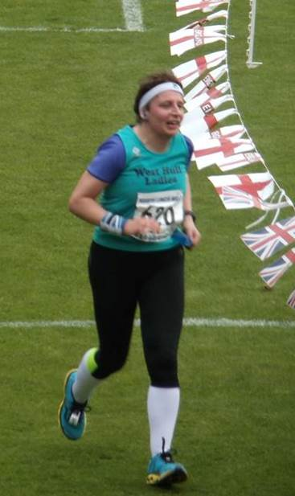
Having stuck my knees together with ‘Rock tape’, I set off at steady pace from the start and felt really quite comfortable. I always do it though…You can guarantee that I take one look at the weather and think…it’s going to be minus 3, hurricane winds and raining cats and dogs…and I’m going to be freezing…so I always start with too many clothes on in races. I should know by now…I’ve been racing for long enough…but no…I plumped for ¾ length tights, a sleeved t shirt under my vest and I even took my rain jacket with me. Needless to say, half a mile down the road I was regretting my decision (duh!). Nonetheless I enjoyed the first five miles even passing the Scunny Bunny (football mascot…I bet he was boiling).

This is a really good event with plenty of water supplied and jelly babies and jelly beans at half way. We got excellent support from the marshals and crowds at various points in the course. I tend to find the section between 8 and 10 miles quite hard going, as it’s very flat and featureless and seems to go on forever, but very soon we are in the final couple of miles with the football stadium in sight. The finish is in the stadium which is really good as everyone gets lots of support. I was shouted in by Debbie, Sandra, Lynne, Zoe and Linda, who had already finished. We then stayed to see Jermaine, who had been coaching Jane, and then Ruth and Sharron finish. I actually got a spot prize as I came in (a pair of 1000 mile socks ☺ which are Zoe’s size…I have got clown size feet so they won’t actually fit me). Linda and Debbie got prizes (awesome) and we must have been the noisiest club in the stadium when Ruth and Sharron finished. Special mention should go to Sharron who was struggling with her breathing during the race, yet still finished and Zoe, who woke up with a cold! I was really pleased with my time as I was generally hoping to be under 2:10 given my poor preparation, and I actually finished in just over 2:07, which was just under 3 minutes slower than last year. This is a really good event and I am looking forward to doing it again next year.

Sharron
'Enjoyment' was the word of the day today!!! ENJOYMENT!!!

Due to the fact I was still having pain in my DVT leg and my asthma was playing up, Ruth and I realised from the off we would probably not be challenging for any trophies this year (huh?)..... A N Y W A Y.......

We certainly didn't need to warm up as walking to the start line did the job, by heck it was a long way. Our super supporters, Nige and Olivia trotted behind after us. Right from the off we set out to enjoy this one. It was just another long Sunday run albeit in a different County and we were in no rush to finish (sorry Nige and Olivia)!! We decided to adopt Amanda's strategy of run 1 mile, walk 1 minute BUT (as so often happens with Ruth and I) that went by the wayside. We set off, the word 'enjoyment' ringing in our ears and, actually, the first 4 miles seemed to fly by. We were taking in the beauty of the countryside......the goings on around us, things were good.

We took in water at around 2 miles then carried on again, happy with the fact the within these first 4 miles we had a few minute walks in reserve. Boy did we need those later on!!! Phew......

4 miles to 8 miles seemed to go ok-ish, although I did have a wobble at around mile 6, I walked for a bit and then it was all over as quickly as it had arrived. This was also the point in the race when we did the 1 minute walk in between miles (though also, this was the point in the space/time continuum where minutes strangely stretched!!!!).

8 to 10 miles seemed to go on forever. We then reminded ourselves that this was an 'enjoyable' run, so we started having occasional chats with those who had turned out to support us and the helpers at the water stations....as you do(!?)

Then, oh my goodness me, 10 to 11.5 miles were a nightmare. Now, there was a group of us toward the back end of this run, and, I kid you not, we practically had games of "tag, you're it" and "follow the leader" all of us, having chats as we kept passing each other and encouraging each other into the bargain. I think also at this point Ruth lost the plot a little and kept chanting to herself.....I just ignored her, she seemed happy enough and wasn't arguing with herself so that was ok!!! I then had a little 'problem' with the ole' running bra.....being (ahem) a larger lady, chaffing had occurred and after a lengthy debate we so very cleverly used my ear protector head band to tie around the afore mentioned undergarment and from then on life was gooooood! The unfortunate bystanders must have thought that we had escaped from the local asylum!!!

11.5 to 12.5 we got our heads together for the approach to the stadium, enjoying the run on the road in. One of our 'tag' runners had warned us about the incline just before the stadium, I'm jolly pleased he did, it was SO STEEP, (the ladies who know me will be laughing as I am known FOR making a mountain out of molehill) for those who don't know me well, the incline was MASSIVELY, HUGELY, INCREDIBLY STEEP!

At around 13 miles we couldn't believe that there were people BEHIND us.....RUTH and SHARRON were NOT the last ones in!!!! We kept looking round in astonishment that there were runners behind us.....UNBELIEVABLE!! We had been looking forward to hearing the life story of the Last Runner Marshal; we felt a little put out that someone else had had that privilege!

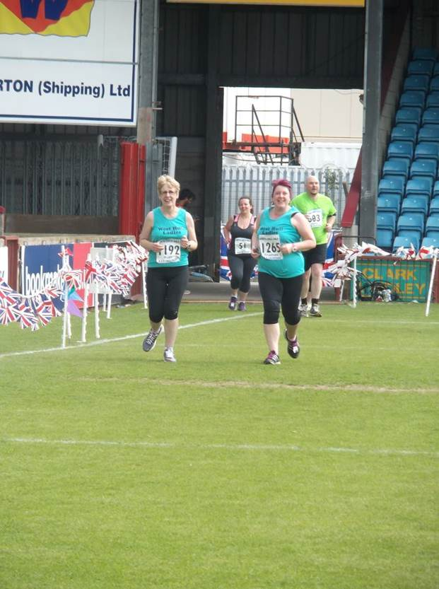
I was always looking forward to running into the stadium, not only for the relief of knowing this 'enjoyable' run was nearly over but for the experience of running into a stadium for the final run in. I've got to say, I became quite emotional rounding the corner and seeing some WHL. We ran through the finish to hugs and congratulations, it was lovely.

Nige and Olivia joined us at that point to congratulate us, then pointed out we were beaten by Scunny Bunny.....oh the shame!!!!!

We finished in a time of 2hrs 52minutes. I wasn't bothered about time, with the problems I'd had in the run up to this, I was just happy to turn up and give it a go.

We set out on this half marathon quite upbeat, which carried us round. We set out to enjoy it, which also carried us round. There were hard times obviously, but we got through those by telling ourselves NOT to get in a state, not to put pressure on ourselves and that we WOULD finish it.....whenever and however......and we did.

Thank you Ruth, for getting me round and to the WHL for their support.

Lynne

Building up to the race I was actually quite nervous because I was having problems through the Champagne League races with both calf strain and shin splints although after physio and some regular exercising this had subsided but not entirely.

We finally decided on the meet time (myself, Jane & Linda), which we changed 3 times from 7.45a.m to 7.30a.m then finally we agreed on 7.15a.m as we didn’t know Scunthorpe very well nor did we know what the traffic was going to be like. Originally Jo was going to join us but unfortunately she didn’t as she was poorly. After comparing notes on everything from what shoes to wear to ‘what clothes are you wearing?’ to ‘what have you got for race fuel?’ we set off. I must admit I felt actually really good on race day, partly because I had really good company and partly because the weather was mild and the sun was trying to break through. We arrived in good time to use the facilities and have a final decision on ‘what to wear’, after making several mistakes in the past with being overdressed and too hot I threw caution to the wind and opted just for vest and shorts, Linda however who originally was opting for just a vest decided against that and went with a long sleeve top underneath. I noted a few people on the way to the start line with black bin liners and I now know my next option when the start line is nearly ¾ mile away from the bag drop. I’ll have to Guccify it though ha! We met up with Debbie and her sister (sorry I forgot her name), Sandra, Jill, Zoe and Jermaine and her son, sorry if I forgot anyone. I was delighted to see toilets at the start line as there were so many nettles along the way it wouldn’t have been pleasant – at least not in shorts anyway!!

Linda, Zoe and I headed for the ‘under 2 hours’ section, at that point I was adamant that I was going to get under 2 hours no matter what but didn’t care how close it was and then we were off. Well actually we were walking as there was quite a crowd and the start was a good half minute off. I set my Garmin but really should have waited until I crossed the start line to coincide with my chip (another lesson learnt)! Both Zoe and Linda pulled away right at the start but I had a game plan to stick around the 10 minute mile marker for the first mile then notch it up a bit for the next 10 then go for it on the last two but best laid plans and all. I actually started a LOT faster than I intended but I was doing really well so I carried on, in fact on one of my miles (going downhill) I had done it in 8.07!! I slowed a little and kept around 8.50 / 9mins miles for quite a distance running behind a personal trainer with a nice butt and his colleague. I was glad I opted for vest and shorts as it was really warm. Also this was one of the rare times I had run without music at that distance and it was a really nice change. The scenery was really nice, the support was amazing, I loved that they shouted your name as you came to collect water. I took a gel with me which as I didn’t have a zip pocket stuffed down my shock absorber and by the time it got to mile 8 and I took it, it was really warm –yuck! I preferred the Jelly Babies at the half way point although I only got two so I had to ask the next marshal for some more.
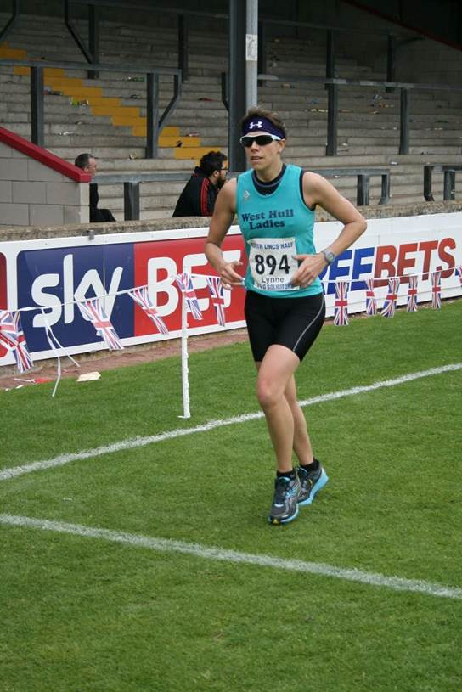
I had Linda and Zoe in my sight (about 50 or 60 meters in front) up to about mile 10 and then it all went a bit wrong. I was convinced that as I was going too fast so I slowed down to just over 9 minute miles and then my knee started hurting, I ignored it but it got worse so I slowed even more and it really hurt. The downhill road run towards the end was a real welcome sight I managed that no problem but I wasn’t very fast. I got towards the final bit and there it was …….a bloody hill, not a big one but big enough that after 12 miles it was drawing some people to a walk. I lurched myself forward using my upper body to get me up it and I did but then coming down was really painful and all I could hear was myself and another chap owwing and eewing and aarghing all the way down. When I saw the sign for 400m I was ecstatic, then it was 200 m and I just gave everything I had left to get to the end and did it in 1hr 58mins and 33 secs.

As my first official Half Marathon race it was a superb experience and I am so running this again next year and thoroughly enjoyed seeing everyone at the end to find out their times and experiences.

Ruth
I know Sharron has done her usual vivid and entertaining description of the N Lincs Half, but I feel I’d be letting the side down if I didn’t add my twopennorth......... so, here goes

1) The excuse
Lack of training (I use it every time)

2) The aims
a) To finish
b) Not to die
c) If things go well, and the fates look kindly on us, to finish in under 3 hours
d) And if thing go even better, not to be last

3) The word
Sharron had decided that our word for the race would be ‘enjoy’. I can think of plenty of race related words staring in ‘en’, like ‘endure’, and, even better, ‘end’, however ‘enjoy’ is not the one which instinctively comes to mind.

4) The tactics
Amanda had suggested running a mile then walking a minute. We didn’t bother for the first couple of miles, but by the end our strategy seemed to be walk a mile, think about running a minute.

5) The race
After a long walk to the start, and me fretting that it was taking strength out of my legs which I could ill afford to lose, Sharron and I settled for loitering at the back. Where else would you look for us? I reckoned we’d be able to keep up with 5 ladies from Caistor Running Club, Sharron reckoned we wouldn’t and, half a mile in, I knew Sharron was right, they were gone. We ambled along looking at the countryside, chatting to onlookers, and generally being us.

The route went on a main road and then turned onto some country roads and we plodded on and on, seeming to be getting nowhere fast, but at least there didn’t seem to be any hills near enough for us to have to run up them. Then we started running alongside the River Trent. We couldn’t see it because of the high banking, but knew it was there because I’d nipped up and had a quick look. I found running alongside the river quite distracting (in a good way). After about 9 miles the route turned away from the river, and by this time we were seriously struggling. We ran and walked and whinged and moaned, we stopped on the side of the main road so I could shove Sharron’s head-band under the clasp of her bra to stop it digging into her back. So she then had a strange lump in the middle of her back, but we were past caring. Just in case you were wondering, Sharron was not wearing her head-band at the time, which would have been seriously weird.

Then (apparently) I started chanting: well, muttering my way through as many Latin verbs as I could remember. Who says it’s a dead language? Sharron just let me get on with it. Presumably she thought that they could soon find me a strait-jacket if necessary. By this time we were nearly at the end of the race, just had to run – or walk - up a mountain (aka the path up to a flyover), over the road, down the mountain, round a few twiddly bits, onto the pitch at Glanford Park, and, finally, the finish.

We’d done it in 2 hours 52 minutes and something seconds. Result!! Less than 3 hours, but, what I want to know is how did Sharron manage to run it 2 seconds faster than me............she obviously cheated.

6) The people
It was wonderful to be cheered in by West Hull Ladies who had waited for up to an hour for us to finish. What a great club!! All the people at the water stations and who had turned out to cheer us on were lovely and positive, especially the cubs and scouts (both boys and girls) at (I think) the 4th the water station. There’s nothing like a group of 9 year olds telling you they know you can do it to make you believe it. And at the end young lads kept high five-ing us and saying how well we were doing.

7) The word ’enjoy’ again
Sharron kept saying that she wanted to enjoy the race, and, saying it did make us think and reassess how we felt. Positive thinking? Or brain washing?

8) The worst bit
At about mile 4, as we approached a crossroads we seemed to be running alone, and there were about 30 people clapping and cheering just us, seriously embarrassing. Now I know how the queen feels!!

9) The best bit
...............err................finishing? Ok then, the really nice people we chatted to; marshals, cheerers-on, other runners, and the sheer joy of running with the seriously wonderful Sharron. She hasn’t paid me to say that, but she might if she reads it ☺
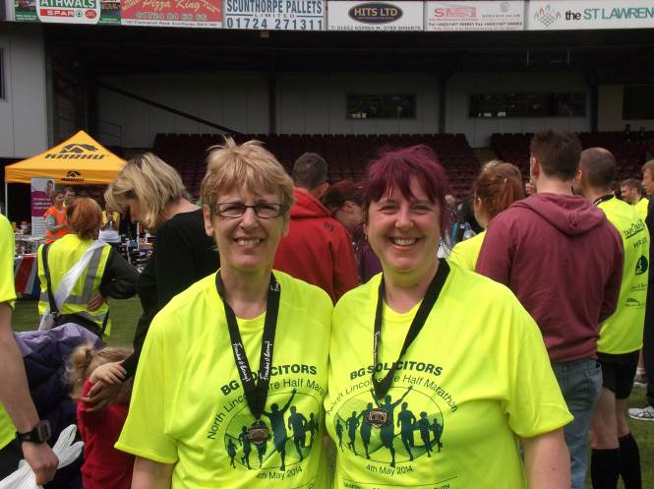
10) Conclusions
a) All aims achieved – result!!
b) It might have been easier if circumstances had permitted us to train properly
c) I like the idea of picking and using a positive word for the race – think it works
d) Job done? Tick

Beverley 10K

Jill
I was looking forward to doing the Beverley 10k. It’s actually the course that I did my PB on last year, and it’s a well organised and friendly event, and provides an excellent tee shirt. There were also lots of our club members doing it, which meant that is would be a good experience. Having done the Lincs half marathon the previous week, I had run out on Thursday for just over 5 miles (because I am still being a bit careful with my dodgy knee)and had felt quite good, so was feeling quite hopeful that I would do a respectable time for me. However on the Saturday I started to feel a bit under the weather! Perhaps it was the effects of watching the Eurovision song contest (!!), and without giving too many details away, my stomach has felt better!

Anyway on Sunday morning, I was in two minds whether to run or not. Anyway me being me decides that I would have a go, and stop if I felt ill. It was great to meet with all of our runners before the race started, although the weather was not looking too promising…Now talking about being 'under the weather', I don’t mind a bit of rain, but the fun-run had already resembled the ‘tough mudder’, so I didn’t think we would get away without getting a bit wet. We all set off, with the temperature being quite warm. Almost immediately I knew my legs felt like I was running through treacle (not that I have ever run through treacle…you understand, but you know what I mean!). I saw Marie and Nicola disappear into the distance, and spent mile 2 going up the hill talking to Steve from ‘White City’ so that kept me going a bit. I was glad to reach the drink station, and then just tried to dig in. At one level it was horrible getting passed all of the time, but to be honest I was pleased to be running, so I just decided to keep a speed that avoided my stomach cramping.

I was pleased to get past half way, which is where Laura passed me (well done to her for having a go despite injury), as there is no turning back and I always feel psychologically better when I am on my way back home. It was lovely to see Jermaine at mile 5, but at this point the clouds had bubbled up again, and it started to spit with rain. Well at this point the heavens literally opened. I have run previously in rain, and I don’t mind it to be honest, as it tends to cool you down, but facing rain that is more like having a bucket of water continuously poured over you isn’t good! My trainers were squelching at each step, the hail (in May?) was horizontal, and the road disappeared under a torrent of water (Oh joy!). The marshals and public were great, as it must have been horrible for them too, and they were encouraging everyone as they went by. Feeling a bit miserable as I turned into the shopping street, my spirits suddenly raised as I saw someone in a finishers tee shirt, and saw that they were long sleeved this year (Yea!). It’s amazing how such little things can be uplifting, although it didn’t stop a number of Cottingham Fitmums beating me to the finish, due to me having a gallon of water in each trainer☹ (poor excuse!). Anyway given my slow time, I suddenly thought I needed to get to the Tee shirt distribution point as quickly as possible so that I didn’t have to take what would be left which is usually something akin to ‘rent a tent’ (this is getting really sad!). Anyway I ran past all of the crowds going towards the sports centre and was happy to be able to get a nice ‘small’ tee shirt☺. (The moral of this story…I’ll do anything for a good tee shirt!). Great performances by all WHL’s, and well done to Rachel Codd for challenging the fact that the women don’t get as many prizes as the men…otherwise our Linda, would have got second prize in her age group (awesome!).

Clare
Wow what a day. I started out feeling so nervous, as this was my first proper race (only ever done park runs and race for life).

I didn’t really get the good night’s sleep I was after, I was too busy watching Eurovision (I know I am a geek). So waking up bleary eyed forcing porridge down was probably not the best race strategy in the world.

Nerves started to settle after seeing all my WHL mates. We were certainly a force to be reckoned with; surely we had the biggest club turnout there?

So, onto the race itself. We formed a little running group in me, Rachel, Shirley, Sarah W, Karen, Kate and I think Suzanne was in there too (there could be more of us so apologies if I missed anyone). As we approached the Westwood our group naturally spread a little and a running trio developed in Rachel, Shirley and I. Kate acted as our pace maker up the front☺. That first “big mountain” was a nightmare. I have run up that hill 3 times now and it seems to get worse each time. Special thanks to Shirley and Rachel. Both of them really helped with those hills, and Codd deserves a medal for her continuous motivational speeches ☺

After the hills we lost our motivational coach to a stitch so it was down to Shirley and me, I am not sure where Kate went I think she had dropped behind us. As the drizzle began it was clear that Shirley could certainly go faster than my pace (I think she was just being nice) so I told her go on without me (sounds a little more dramatic than actually happened). Running by myself was strange but my legs just kept going and I got a little pace up. It was great to see Jermaine on the Westwood it really spurred me on. Even though all the spectators continually shouted “Well done West Hull” or “Come on West Hull” (a little strange being an East Hull Bird) at me, it made me feel very proud each time, it was even better seeing a friendly face in Jermaine cheering for me as I approached. After that I didn’t feel the blister developing or the tight calves I just felt I had that bit extra. So I was on the home stretch and running on the cobbles (not a fan I must add) and just went for the finish. Mamma and Papa Hoe had turned out in the rain to cheer me on which was absolutely amazing. I have now told them that they need to come to all my races. They didn’t look overly enthusiastic dripping wet but hopefully not all of them will be horrendous weather.

There are a few mentions that are required. A few special thanks need to go to Jermaine, firstly for the letting me borrow her Garmin and secondly for the support. It really made such a difference. Sandra was great, I don’t know how she does it but she just seems to pop up everywhere☺, she always looks after us 0-10kers (see what I did there☺). Kate and Carol for investing the time in us. We would have never got to a 5k let alone a 10k without you both helping and teaching us along the way. Finally the ladies that stayed in the rain dripping wet, waiting for each of us to finish, it was amazing to have you all cheering for me as I crossed the line.

So overall for my first ever race I can give it a massive thumbs up. Aching today but that is because I am now a runner who competes in races☺.

Sharron
I was looking forward to the fact that there were going to be LOADS of us WHL descending upon Beverley to take part in this race, hope Beverley was ready for us! Arriving with Nige and Olivia in tow, it didn’t take long to spot everyone. It was a great sight. We got together for a huge photo call then made our way outside.

We all lined up at the start, all happy and excited, some of the newer ladies were nervous, I was just hoping the rain would stay away....and then off we went. For a long while Ruth and I followed Suzanne, and we knew there were a few WHL following right behind us, I could hear the encouragement from bystanders for those in front and those behind us. It was nice to hear.

Ruth suggested we should walk up the hills, I never argue with what Ruth suggests, she is usually right, wouldn’t tell her that though.....even so, I think the first one we ran up most of it, which I was pleased about.

Just before the first hill, we saw our friend and ‘long lost’ Last Runner Marshal, John, from the Major Stone Half, OH THE JOY! Our hearts lurched (especially Ruth’s as she had flirted with him more than I did....that lass....honestly....) It was great seeing him today though, I noticed he kept riding back to check on us AGAIN, I’m hoping it was purely because we became firm friends as we were with him long enough (at the Major Stone) to enable us to get to know his life history, but I fear it was probably because he saw the state of us and, remembering what we were like last time, couldn’t believe we were still running!!

Water station ahead, “great”, was feeling rather warm by that point.

Two miles soon came and went, everything felt ok, we were still moving, still chatting slightly. We walked a little way up the second hill, kept running up on Ann and Anders, who were both looking good. We were spurred on by ‘The Lady in Black’ as she threw some kind words our way, telling us that when we started running again after walking up the hills, we looked strong and kept good pace with one another, she even went so far to say we ‘got a trot on’, thanks ‘Lady in Black’.

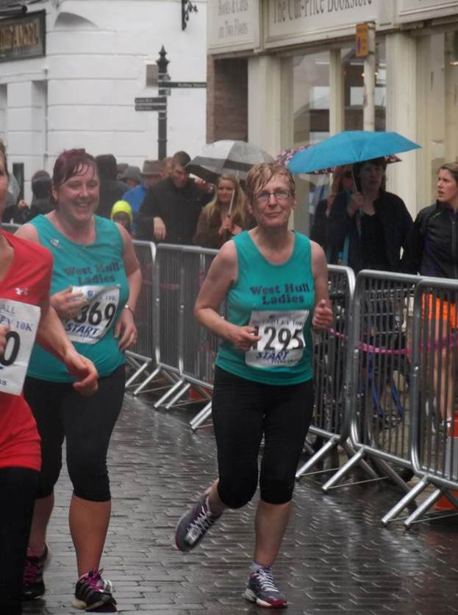
Now, I’m not keen on the middle part of this run, I find it quite boring, so I’m glad when we hit the Westwood with around 2 / 2 and a half miles to go. Though, when we did hit the Westwood this year....blimey oh riley.....the wind howled, the rain pelted sideward’s, whipping and stinging our faces....OMG it was awful. There was no cover, it was just head down and go....and believe it or not....go we did. This seemed to spur us both on as we obviously wandered into what proper runners would call ‘the zone’.....Ruth and I never hit ‘the zone’, so it came as a bit of a shock to us when we were in it!!! We came through the rain and just ran, keeping a good rhythm. As we dropped down toward the houses, I could sense Ruth was feeling good too, everything felt right and we knew we’d feel this way to the end, and we did. We even crossed the line on a sprint finish.

I really enjoyed this race, even with the rain.

Unfortunately, we were dashing off to see Hull City so we couldn’t hang around and wait for everyone to come in but at least we managed to see a few WHL run in just behind us.

Well done to all, well done to the newer ladies, great achievement!!
Ruth
My race report, not my best, follows......................
Super supporters Nige (Sharron’s husband) and Olivia (Sharron’s younger daughter) drove Sharron and me to the race. Well Nige drove and 8 year old Olivia shadowed him. To say it was raining was an understatement, it was tippling down, and Sharron and I had our usual ‘why are we doing this?’ conversation.

Anyway we got there and it was AMAZING how many West Hull Ladies were there, including loads of new ladies all raring to go and race, and super-supporters like Jermaine, Carol Holmes, Karen’s mum (and Nige and Olivia obviously). It was great to see Emily with Debbie and Bex; a speedy family trio if ever there was one. After a complicated photo-session, we all made our way to the start, and Sharron and I ambled off. Suzanne set off at a really determined pace and soon put some distance between herself and us, Ann was running along steadily with Anders (not seen him for a while, hasn’t he grown), Sharon and loads of other ladies just disappeared into the distance and Sharron and I settled into our run. Saw Carol, and then Annette and Jermaine supporting, gave them a big wave, and a shout. Our strategy (well, mine really) was to walk up the hills, and attempt to run the rest. This was further refined to include walking to and after water stations. Anyway, we’d passed Ann and Anders, then they passed us, we passed them, they passed us again, and that was it, they disappeared into the distance. Just at the top of the Westwood it started to rain. Actually to say ‘it started to rain,’ does not even begin to describe it; there was sleet in the rain and it was raining horizontally and we were drenched. Anyway, the only way to get out of it was to run through it, so we did. As we went down toward Beverley the rain seemed to ease (good), we were overtaken by Shirley looking comfortable (so impressive) and then Sharron and I put on a bit of spurt to the finish. Wanted to look good – if only. It was great to see so many West Hull Ladies everywhere, and all looking pleased.

I wanted to finish by 12.30 and we did, in 1 hr 13 mins and some seconds. We queued in the rain for our tee-shirts and then rushed to Sharron’s car. Nige drove us back to Hull while Sharron and I had a picnic etc, then we rushed to get ready to see Hull City play Everton.

It was a good race, despite the weather, (can’t believe I wrote that), a huge ‘well done’ to everyone, especially those ladies who only 4 months ago were just starting to run with the club. I seriously hope you are proud of yourselves, you certainly should be. And I’d like to say thanks to Sharron, Nige and Olivia for looking after me so well again.........you are great.

P.S. I forgot, until Sharron reminded me, that the love of my life, John, who the last man marshal when Sharron and I ran the Major Stone Half Marathon last year, was marshalling. My heart started beating faster (or was it just the running) and I shouted to him to ask if he remembered us. He said ‘I do now I’ve heard you heckling me’. My hero.

London to Brighton

Ann

This was always going to be a different event to anything else I had done before - today was for Daisy, 100km is a long way, and it was a serious task ahead.

So no chit-chat, no race buddies - just me and my thoughts, me and Daisy … except it didn’t turn out that way in the end.

The London 2 Brighton Challenge event is different to other ultra marathons in that it offers a fantastic level of support for participants. Other ultras can consist of a route card, some feed stations if you’re lucky and your name on a finishers list at the end. This was more of a big marathon experience, and then some.

I arrived at 5.10 to register, which took a couple of minutes, and then I had the luxury of a very big marquee with seats and tables to wait in for my 6.20 start … and no toilet queues!! I chose not to start chatting with folk, and just waited calmly for time to pass and for the rain to keep coming. I took off my warm layers, dropped off my bag to be transported to the half way point, and wandered over to the start area for the warm up.

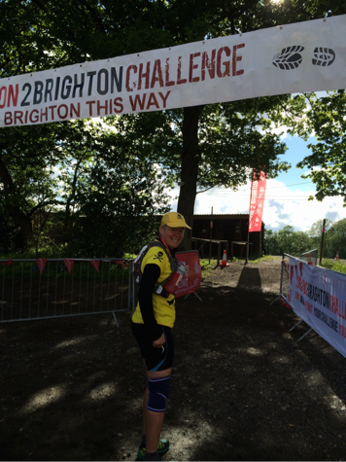
Ha! Warm up? - I was not in the mood for dancing to music, so did some heel raises instead to loosen up my poorly Achilles. 10 minutes later we were scanned into the start pen, they counted down and we were off … slowly … It was weird seeing people running so sedately. It was not difficult for me to keep my pace down - I’d read that I should imagine running at the pace I’d be running at the end … (if only I’d known what was ahead!).

The first part of the route followed the Thames past some very posh houses and some interesting house boats in a continual downpour. (My knickers were wet after about 15 minutes of the start, if that’s any guide). I kept smiling to myself having been such an optimist that I’d actually put sun cream on that morning!

It wasn’t that long before the faster runners from a later start began to overtake me - participants were starting off every twenty minutes until about 11 o’clock. It was strange, getting into double figures of mileage and thinking that some hadn’t even started yet.

There aren’t a lot of trails in London, so the road running went on and on. The whole route was really well sign-posted - this was an ultra for the geographically challenged. No one should lose their way, unless they were not concentrating and missed an arrow. I saved three runners from this as they merrily ran past a turn-off and I shouted “LEFT” at the top of my voice! Later in the day I met a guy who had missed a turn and done 7 extra miles!!

Feed station one came at 12.5km - sweets (no, not interested), chocolate - (it really was ‘Happy Shopper’, so that was a no, too), tea, coffee, water and Hi5. I filled up with water, had a wee and carried on.

More roads, a big hill, and then feed station two was a bigger one, so here there was cake. Now to those who did Golden Fleece - the cake here was even better! I didn’t fancy much, so broke a flapjack and a brownie in half and munched on them whilst walking to the loos. They were melt-the-mouth gorgeous, so after my loo stop I went back for the other half!

Those cakes gave me the biggest lift … I ran well after that - for a while, anyway, but I didn’t start this run in the greatest shape, and the creaks and groans were starting to get me down. On top of my knee thing (Jamie said what it was, but I can’t remember - something to do with a cling film tear thingy), Achilles problems on both legs, my hip had also been hurting since about mile 3 and no amount of stretching would ease the discomfort. Crossing the M25 was a bit of a milestone, but this was followed by the disappointment that Dad hadn’t managed to make it through the traffic to the agreed meet up point by the time I got there. A couple of miles later, though, I came through a village that I thought Dad might able to get to, so I waited, and by the time the family arrived I was quite emotional. I needed the comfort of my family around me so much at that point. So, a hug from everyone, then I had to pull myself together, and keep going.

The first 6 hours had been constant rain, and when the London roads became the trails of southern England, so came the mud. This was slippy,-slidey-continually-wet-feet-type mud, which was bad enough, but when this occurred on steep inclines in woods with tree roots and stumps everywhere, this was a very long way from the pavements of the Avenues I’d trained on. The Golden Fleece was a woefully inadequate training run. I was finding this very hard indeed.

But woods don’t go on forever, and the deep muddy parts eventually became solid ground again, and the woods became fields or paths again, and I was a few more miles further on. And then I started running with another guy, or rather he started running with me. Ordinarily I’d be glad of the company, but not today - he was a nice enough fella, but I wasn’t here for a social event. I ran that bit quite fast, relatively speaking. He was glad of the pacing I was offering him, and then another chap joined in as well. It helped me to keep running, and it was at this point I realised the pain in my hip had subsided - a 44km warm up!! I didn’t want the company, though, so I broke my rule of walking the hills, and kept pushing enough to leave the two guys behind me.

Eventually I reached the 56km feed station, which is the key rest point on the route. This was a big area and I was ready for a rest. I got a lot of clapping and was delighted to spot my family, and to pick up my bag that had been transported from the start, and to sit down for a rest. The food on offer here was substantial, but I couldn’t quite stomach a big feed. Instead Anders got me some cakes and a couple of sandwiches while I took care of my feet. They steamed! I’d packed a blister kit, but hadn’t practiced taping, and my efforts to tape the hot spots on my little toes failed, so after a bit of a sit and a chat I made my way over to the First Aid tent. At this point I was so happy with my family, just sitting and resting, I couldn’t work out how I’d get myself ready to go any further.

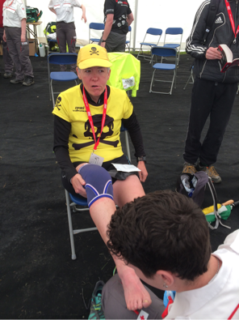
… and this is when I learned the importance of a support crew for ultra running. The official support was ok - I knew that the taping young Harrison did on my hot spots / blisters was poor, but he’d done his best, bless him, and his supervisor was very attentive, which was lovely. But Carol and Anders were fabulous. As I had my feet seen to, Anders rushed about here and there, filling my water and Hi5 bottles and getting cakes, and Carol was, well, just there - saying all the right things, and putting my mind at rest. I was really aware that even my conservative estimates for the day were now hopelessly unrealistic, and that I was about to impose a much later night upon my family than I had originally intended. Carol told me just to keep going - they didn’t mind, they were right behind me. What a difference that made - she told me about all the supportive comments on Facebook - everyone was rooting for me - those back at home, and my special crew there in Sussex.

… so I carried on, armed with clean, dry taped feet, fresh trainers and socks, and a little head torch, since Carol had worked out that I’d be losing the light before I met up with the family again and may need it.

… And it had stopped raining …

Another hill … and then another …

Less mud on this stretch … but more pain, at the front of my ankle this time, and this pain wouldn’t shift either. This time it was painful to run, and it didn’t feel like the type of pain to just put up with.

I walked, a lot, but the problem with that was that I wasn’t moving quickly enough to stay warm, and I hadn’t eaten enough of that lovely food at the feed station. I was struggling to chew my energy bars, and when I tried my trusty Torq gels, it took far too much effort even to consume one of those. The 11km to the next rest point seemed to take forever, and I was in a bad way. I went to the medics who gave me a full check - blood pressure, temperature, oxygen something, blood sugars, and an emergency blanket. That little foil sheet was instantly comforting, and the outcome of the medic assessment was that I was healthy enough, but should rest the foot (ha! rest!), and eat chocolate. It was wonderful to be instructed to eat chocolate … but Happy Shopper? Was I really that needy?

I needn’t have worried - the snack tent had Snickers bars and Jaffa Cakes, so I troughed the lot, with a coffee and then a banana. With my emergency blanket wrapped around me and a couple of Paracetomol and a ton of chocolate inside me, I set off again … feeling warmer and more sustained. I don’t ever take painkillers when I’m running, so I was amazed how well they worked - I was actually able to run a bit now, but not for long, since the mud returned, with a vengeance. This was even worse than before - and I knew that with fatigue factored in I had to put all my concentration into moving forward but staying upright and avoiding injury. I picked my way down the steepest, darkest, rootiest, branchiest, muddiest valley, just concentrating all the time on where each foot would go - stay in the moment, don’t fret - it won’t go on forever … and then all of a sudden the path led onto a wooden footbridge across a large river, with a photographer at the other end. I saw him arrive from the road ahead of me - he’d found his way down that same valley, but with two expensive cameras in his hand!!! They haven’t been published yet but that will make a really lovely photograph, since it was really sunny at that point.

So whilst I was very noisy, the emergency blanket was doing the job, and my mood picked up. The painkillers became less effective, and the running became less and less, but with Carol’s reassurance, I kept going, with the knowledge that the family were behind me, and weren’t cross at keeping them up so late.

By the time I got to 70km, it was head torch time, and the optimist that I was, I’d planned to get the better, heavier one from the family at the 80km rest stop, but this smaller one was not up to the job. I had to hold it in my hand as close to the ground as I could to see where I was going. Clearly (ok, poor choice of words) this slowed me down even more. The mud was shoe pulling off mud, and I couldn’t even see it! It was just horrible, crappy, scary, and lots of those sorts of words - someone on Facebook called it ‘Mud Tourettes’. But I was able to hold myself together - concentrate, wet feet won’t kill me, and any step taken slowly enough won’t injure me, so just keep moving forward, but taking care.

I never wanted to do night running, and to be fair, I didn’t run very much at all - this was night walking, but in a perverse sort of way, I did quite enjoy this. It was so, so difficult, and yet I enjoyed tackling each section, and the relief of any section that was firmer, or more open. I really loved spotting the next glow stick. Navigation at night was a cinch - every corner, and I mean, every single corner, was illuminated with green glow sticks. Each time you turned left or right, you looked ahead, and you’d spot another green line in the distance. It was so very peaceful - there was hardly anyone around, just me and the terrain, and not a sound, apart from my crinkly blanket, that is.

The next meet point was 80km - where I met my family and learned they’d missed dinner, trying to drop off bags in Brighton and get back in time to meet me. And Anders was so full of encouragement - if you knew anything of Anders’ background you would appreciate how significant and generous this was. For Anders to be deprived of food is his worst nightmare - and there he was, hungrier than he’d been in many years, in the middle of the night, and still looking after me, and supporting me. That, my friends, was breathtakingly moving.

So, armed with two heavy duty head torches, five layers, minus the emergency blanket, I set off once again, more quietly this time! The next section was a bit easier, and 7km later came another opportunity to stock up on crisps and hot chocolate this time, to prepare for the big pointy hill - over the South Downs. Here’s the elevation profile -
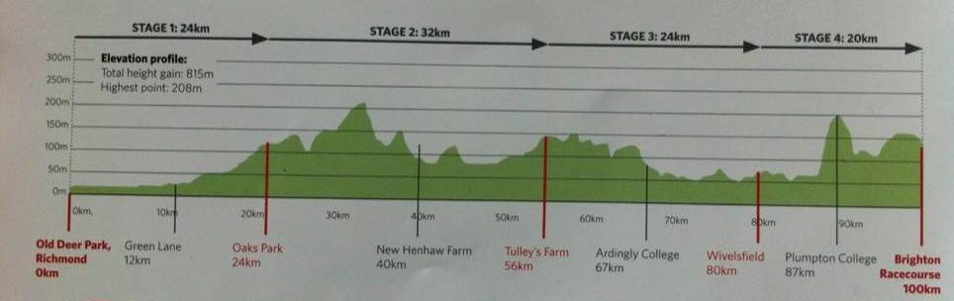
This hill was a toughy, but I decided to use the same strategy as the mud - it’s hard, but it won’t last forever, so just keep putting one foot in front of the other - take a quick breather, if you need to - but move forward, do it for Daisy. This time the green glow stick wasn’t in front of me, it was in the sky!! And so the South Downs came and went - up and over, and the terrain wasn’t too bad, especially with my powerful head torch showing me the way (thanks, Sandra).
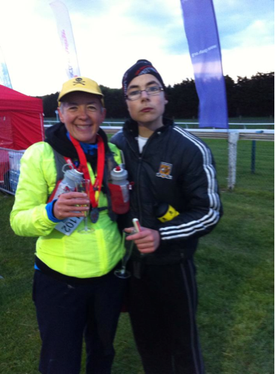
Some weeks ago Anders had asked if he could do the last 5km, with me, and we found a good place to meet at 94km, and there he was, at about 4 o’clock in the morning, with a big smile across his face, ready to do his bit. A quick hug and a kiss from Carol and Dad, and then off we went together. He talked incessantly, about all manner of things - his teacher Gavin, guns, the moon, the run, Daisy - I love that boy. It wasn’t that long before I was able to switch my head torch off - the birds were singing and we’d walked through the dawn - a precious memory indeed.

We kept counting down the km markers and when we got to 99 we were at the far end of the racecourse, and could see the finish ahead - up another incline! He was happy, I was happy, and then I could see Carol and Dad too. We crossed the finish line together, and was given a glass of champagne, my medal and my T-shirt, but when we got indoors, and met up with our Brighton hosts, Chris and Suzanne, Carol had bought a big bottle of bubbly for us all to share - happy days!

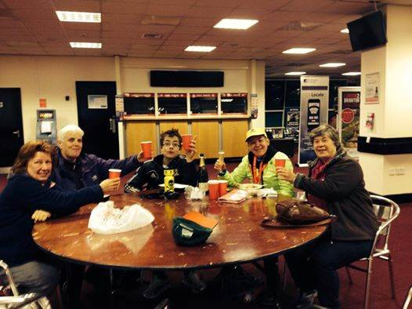
I wanted to finish with a little reflection on running for a charity. This is the fourth time I’ve run for a charity. I know that not everyone wants or is able to donate, and I also understand that in a running club it’s often the same people that are being asked to donate to one cause or another. My opinion on this is that if you want to do something that’s important to you, for whatever reason, then do it, because many people will donate. I know that the minimum amount to raise for London Marathon is a big challenge, but other events are not so demanding, and I found that having a reason for doing a challenge such as this made it so much easier (?!) to complete. It adds another dimension to your running - and when you become aware of just how much support there is, then you can keep moving and keep trying, because it has become a team effort.

So there it is - what I thought would be a solitary affair, with just me and the distance was in fact a team event in the end, because my family, my sponsors and all the support from friends, family and WHL along the way got me to the finish line -

Thanks, everyone!!

www.justgiving.com/daisyholmes

Spurn Point Run

Anna
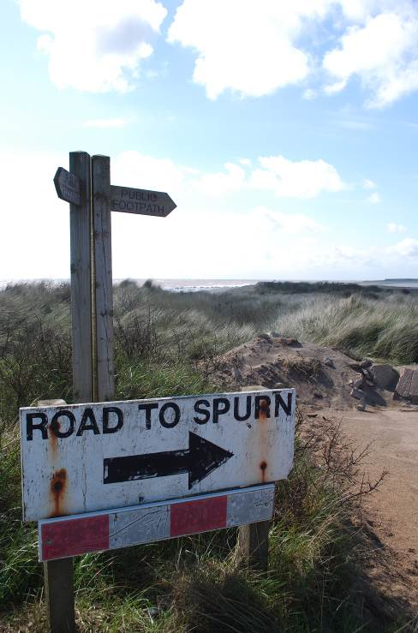
I grew up in Withernsea- and our favourite way to spend a Sunday was a walk on Spurn Point. Since then I have been a bit obsessed with the place. When I was an art student in Scotland, Spurn and the coastline at Kilnsea provided all my inspiration. I could rattle off 3/ 4 films in one go- when you had to put a film in the camera then send it off to be developed! And my sketchbooks were always filled with sand!

Running is a more recent hobby, and since being able to tackle longer distances, I have always meant to run along the point- it is 3 miles to the tip, so 6 miles total- with a lovely tea shop at Kilnesa to end with! Perfect setting for some quality running time.

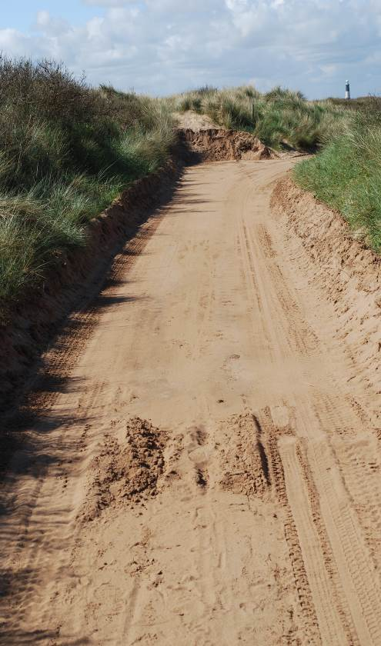
Winter 2013/ 14- the point was breached by a tidal surge, and now it has changed dramatically. It is unrecognisable from the place we used to drive down. Typical then- that I waited until this year to have a go! I was still keen to do it, and was curious about the changes to the landscape.

I arrived on a superb sunny crisp morning and parked the car at Kilnsea.

I went straight to the YWT office to find out about tide times- the point is now covered at high tide each day. Love the place but didn't really want to get stranded! I was assured that I would be fine, but less happy when the warden said “don't worry- there is a shelter if you get stuck”- hmm. There is motivation to get on running! I had intended to spend time with my camera first, then come back to the car- leave the camera and head off properly for a run.

Well- it didn't go to plan. I saw the damage that the sea had made, and was clicking away with the camera- jogging along to the next interesting view point, when I realised that I had come too far along and would never want to put the camera down anyway- so should just get on with it and run.
Sand is not an easy surface for running- such hard work- so I made sure that I had to stop lots at that point!

Due to the changes there- about a mile was just beach, so as soon as the dunes started and the old road re-appeared, it became much easier to run. I still found it hard going. I realise how much I keep my head down when running- watching my trainers hit the concrete- but that was hard to do here- the setting was too interesting to miss.

I am also not used to running completely in solitude. Even without the club, there are other runners, traffic, noise- here nothing- which was quite lovely- just different.

I managed a slow run to the lighthouse, where I started to see lots of the “killer caterpillars”- not quite as dangerous as they sound, but some people have had bad allergic reactions to them. So I had a little stop, and then turned back. It seemed much quicker on the return- maybe I was just getting into my stride.

I ended at the Bluebell for a huge mug of tea, and then headed home. I probably ran about 4 out of the six miles, and found it really hard going- but had such a good time.

The setting was fabulous, and shaking sand out of your trainers is a lovely feeling!
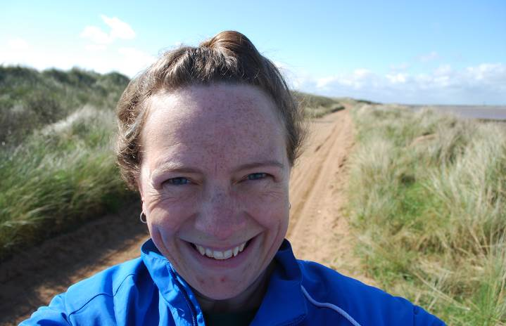

Summer Running Hazards

I saw this on Women’s Running and thought some of the tips might be useful now it’s starting to get warmer.

Summer often brings potential hazards for outdoor runners. Find out how to avoid, tackle or navigate these pitfalls - some of them may surprise you!

Cyclists
When the sun's out, fair-weather cyclists take to the roads and cycle paths. You may find yourself sharing cycle paths, byways or canal towpaths with more cyclists than usual, and many of them might be children, or inexperienced, unconfident adults. So take care and take responsibility. If you must wear headphones, make sure the music is turned down low enough that you can hear bikes coming up behind you. If you are running towards a cyclist, clearly signal (with your hand) which side you are going to pass them on, then run confidently on. If the cyclists are very young or look very wobbly, consider slowing down or even stopping to let them pass.

Dogs
Dog walkers enjoy longer walks and rural rambles on dry days. Although they ought to put pup on the lead (or make him sit) when a runner is approaching, many will not. If you are wary of dogs, or of this dog in particular, you are well within your rights to stop, and politely ask the dog owner to call their dog to heel and/or put him on the lead so you can pass. If you are OK with dogs, run confidently past and don't make eye contact with the dog or make any gesture which he could misconstrue (hands in pockets can mean "biscuits"!) If the owner does control the dog, be sure to say a quick "thank you" as you pass.

Flies And Midges
Ugh, there's nothing more frustrating than a humid Summer run accompanied by flies, midges and other buzzing beasties. If you know that your local running route is prone to midges, avoid it during particularly hot times of the day. Canal banks, lakes and ponds are common culprits. Invest in some insect-repellent wipes (not all of them contain deet) and wipe your arms, legs, chest and shoulders before you set off. You could even tuck one into your shoulders strap or waistband. Try spraying a running cap with insect-repellent before you set off (spray it before you put it on). This should keep the worst of the buzzies away from your eyes and mouth.

Heatstroke
If you've ever had heatstroke, you'll know how horrible (and potentially dangerous) it is. Do everything you can to avoid it in the first place: keep very well hydrated during the day, and start every run properly hydrated. Take water with you (in a camelback or similar device) or stop for water along the way if you're on a long run. Protect your face with a cap, and wear cool running kit which wicks sweat. Run in the shade wherever possible, and avoid the hours of 11am-2pm if you can. If it's really hot, soak your running hat and even your t-shirt in cold water before setting off.

Sunburn
Even cool summer days can cause sunburn, particularly if you have fair or red hair. Use a sport-specific sunscreen on any exposed skin, including your face and the parting in your hair, and consider taking a small tube of sun block with you if you're off on a particularly long run

Grit And Gravel
If your run takes you off-road, the hot weather might turn footpaths into dry gravel and grit which you kick up as you run. What's the problem with that? Try running with a tiny chip of stone down your sock and you'll soon find out. To combat this small but oh-so-annoying problem, try wearing long, tight socks (such as compression socks).

Racing and Running Events
Fancy something different? For worldwide marathons click here

Date/Time | Event | Fee | Entry forms | Online entry
June 2014
8th/09:30 | Jane Tomlinson Hull 10K | £26 UKA/£28 | Online entries only | online entry
15th/11:00 | Burton Pidsea 10K | £8 UKA/£10 | Entry form | Online entry (+£1)
22nd/09:30 | Jane Tomlinson Pennine Lancashire 10K | £16 UKA/£18 | Online entries only | Online entry
29th/09:00 | Humber Bridge Half Marathon | £20 UKA/£22 | Entry form | Online entry
July 2014
11th/10:00 | Walkington 10K | TBC | TBC | TBC
20th/09:30 | Jane Tomlinson Leeds 10K | £26 UKA/£28 | Online entries only | online entry
August 2014
3rd/09:30 | Jane Tomlinson York 10K | £26 UKA/£28 | Online entries only | online entry
20th/08:00 | LDWA Smugglers Trod | £10 | Entry form | Postal entries only

Please remember to double check dates, times and entry fees with the official website or the entry form.

www.westhullladies.org.uk/races.htm Zoe, Racing Officer

NOTE: Club Vests must be worn at any races you enter
under the West Hull Ladies running club name.

West Hull Ladies Road Running Club
Kit Order Form

FORENAME ___________________________________

SURNAME ___________________________________

ORDER - tick what you require, with size Price

- VEST SIZE ___________ £16.00
- LONG SLEEVE TOP SIZE ___________ £18.50
- BEANIE HAT £6.50
DATE Ordered _______________

AMOUNT PAID _______________

Please transfer payments online with your name and marked as ‘Kit’ to:
Account: 63762742 Sort Code: 20 43 49.
Or cheque payable to ‘West Hull Ladies RRC’, and write your name and ‘Kit’ on the back and give to Club Treasurer Debbie Watson, 51 Westbourne Ave, Hull.

Sign on receipt of goods _________________________________

DATE _______________

Please complete this form and email to diazmaria@btinternet.com

Thanks.
Maria
Kit Officer

